REACT ASSIGNMENTS
Assignment 1:
Creating a React Application
Aim
To install React, create a new React application using Create React App, and display the heading "Welcome to the first session of React" in the browser.
1. Create the Project
npx create-react-app myfirstreact
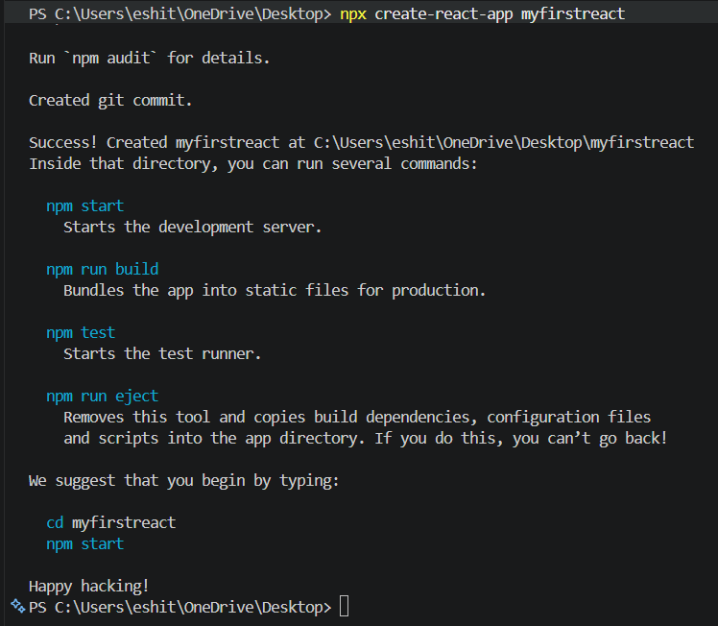
2. Go to the Project Folder
cd myfirstreact
3. Open the Project
code .
4. src/App.js
function App() {
return (
<h1>Welcome to the first session of React</h1>
);
}

export default App;

5. Run the Application
npm start

6.Output
